**WEEK 2**

**Q3**

class series{

public static void main(String args[]){

int s[][]=new int [4][];

s[0]=new int[1];

s[1]=new int[2];

s[2]=new int[3];

s[3]=new int[4];

int i,j,k=1;

for(i=0;i<4;i++)

for(j=0;j<i+1;j++){

s[i][j]=k;

k++;

}

for(i=0;i<4;i++){

for(j=0;j<i+1;j++)

System.out.print(s[i][j]+"");

System.out.println();

}

}

}

**Output**

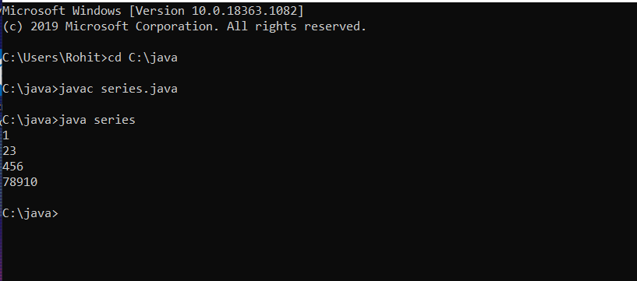

**Q4**

class student{

public static void main(String args[]){

int math=28;

int mathsee=78;

int total=math+mathsee/2;

if(total>=90){System.out.print("S grade");}

else if(total>=80 && total<90){System.out.print("Student got A grade");}

else if(total>=70 && total<80){System.out.print("Student got B grade");}

else if(total>=60 && total<70){System.out.print("Student got C grade");}

else if(total>=50 && total<60){System.out.print("Student got D grade");}

else if(total>=40 && total<50){System.out.print("Student got E grade");}

else if(total<40){System.out.print("Student got F grade");}

}

}

**Output**

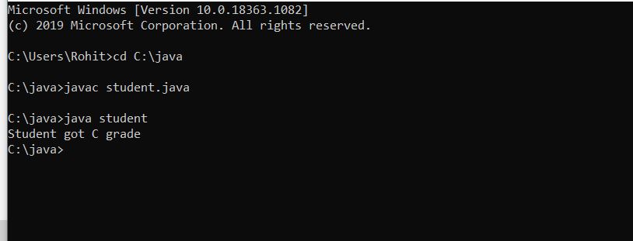

**Q5**

class primes

{

public static void main(String args[])

{

int a;

int b=20;

for(a=2;a<=b;a++)

{ int f=0;

for(int k=2;k<=a/2;k++)

{

if(a%k==0)

{f=1;break;}

}

if(f==0 )

{System.out.print(a+" ");}

}

}

}

**Output**

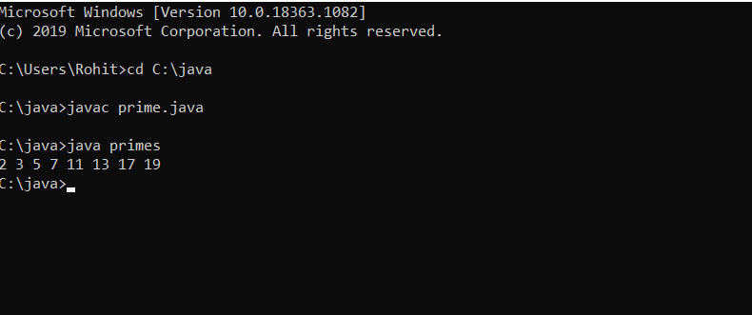

**Q6**

class areavolume{

public static void main(String args[])

{

double r=15,h=25;

System.out.println("radius is "+r+" and height is "+h);

double Ca=2*3.14*r*h+2*3.14*r*r;

double Cv=3.14*r*r*h;

double ca=3.14*r*r+3.14*r*Math.sqrt(h*h+r*r);

double cv=3.14*r*r*h/3;

double sa=4*3.14*r*r;

double sv=(4/3)*3.14*r*r*r;

System.out.println("Area of cylinder: "+Ca);

System.out.println("Volume of cylinder: "+Cv);

System.out.println("Area of cone: "+ca);

System.out.println("Volume of cone: "+cv); System.out.println("Area of sphere: "+sa);

System.out.println("Volume of sphere: "+sv);

}

}

**Output**

